TECHNICAL PROJECT REPORT

# Title of Invention / Project:

Ultrasonic Height Measuring Device.

# Team Members / Inventors:

|  |  |  |  |  |  |
| --- | --- | --- | --- | --- | --- |
| **S. No.** | **Name** | **Department** | **Designation** | **Mobile** | **E-Mail** |
| 1. | Munish Kumar | ECE | STUDENT | 7006855895 | munishkundal24@gmail.com |
| 2. | Navdeep Singh | ECE | STUDENT | 9872952407 | light.77.y@gmail.com |
| 3. | Khushal Thakur | ECE | Mentor | 9646030764 | khushal.thakur@cumail.in |
| 4. | Anshul Sharma | ECE | Mentor | 9478697475 | anshulsharma.ece@cumail.in |
| 5. | Kiran Jot Singh | ECE | Mentor | 9463909689 | kiranjotsingh.ece@cumal.in |
| 6. | Divneet Singh Kapoor | ECE | Mentor | 9878422653 | divneet.ece@cumail.in |

Section – 1 (IPR Related)

# Brief Abstract (500 words)

The project deals with easy execution and operation in distance and height measurements, using hardware description language.

The distance as well as height is measured using ultrasonic sensors and programmable digital display.

A Stand can be installed for easy execution of height measurement.

# Existing state-of-the-art and Drawbacks in existing state-of-the-art

(*Brief background of the existing knowledge*)

|  |  |  |
| --- | --- | --- |
| **S. No.** | **Existing state of art** | **Drawbacks in existing state of art** |
| 1 | Ultrasonic height measuring device | 1. It cannot be used under water. 2. It have a limited detection range. |

# Novel/Additional modifications that you can propose to improve upon drawbacks

* Do not require any physical requirement.
* Do not require any meter tape.

Advantages:

1. The execution and operation is feasible.
2. Precise measurement of height in given units.

# Block Diagram:

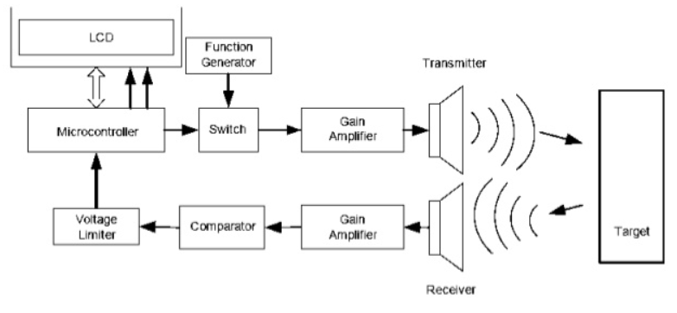

Section – 2 (Real Project)

# Materials:

* Arduino Uno micro-controller. (500 rupees)
* Breadboard. (80 rupees)
* Connecting wires. (50 rupees)
* Ultrasonic sensor. (200 rupees)
* Programmable Digital Display. (200 rupees)

# Circuit Diagram

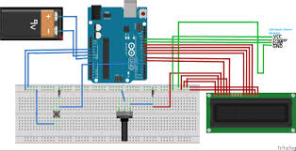

# Steps of Circuit Completion

1. We took Arduino.
2. Ultrasonic sensor.
3. LCD and connected there circuit as shown.
4. Then we done coding of the project.
5. And finally project is ready to measure the height.

# Program Code

https://github.com/Parallelsnap/Munish-kumar.git